STAND-UP COMEDY · PRESS KIT
Meredith Kerr
The Queen of Blue Ridge Comedy — fearless punchlines wrapped in glitter, sobriety, and Southern grit.

BRISTOL, VA · TOURING NATIONWIDE
EST. 2021
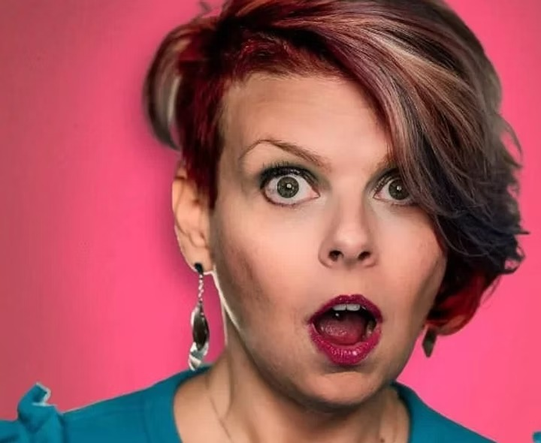

THE STORY
About Meredith
A sparkly, Southern unicorn — bright, bold, and brutally honest comedy from the Blue Ridge Mountains.
Meredith Kerr is a fearless, witty stand-up comedian whose sharp humor and relatable storytelling have quickly made her a standout in the comedy world. She first burst onto the scene in 2021 in Northeast Tennessee, where she honed a unique comedic voice that blends bold punchlines with introspective truth.
Her material is a refreshing mix of unfiltered honesty and razor-sharp observations — whether she’s chronicling life in sobriety, navigating the rollercoaster of singlehood, or diving headfirst into the chaos of everyday mishaps. Audiences appreciate her willingness to get real and her knack for turning personal experiences into uproarious comedy.
Since her debut, Meredith has performed at festivals including World Series of Comedy, Rogue Island, and Lookout Comedy Festival, and in 2024 was crowned Blue Ridge Funniest. Her fearless attitude and quick wit have landed her on stages across the country — from Anchorage to Michigan and everywhere in between.
★ SHORT BIO · FOR POSTERS & BOOKINGS
Crowned the 2024 Blue Ridge Funniest, Meredith Kerr is a touring stand-up comedian from Bristol, VA whose unfiltered honesty turns sobriety, singlehood, and small-town chaos into bold, bright, can’t-look-away comedy. Festival credits include World Series of Comedy, Rogue Island, and Lookout.

RECEIPTS
Credits & Festivals
2024  Blue Ridge Funniest  Winner · Regional headlining title |  | '24  World Series of Comedy  Festival performer
'24  Rogue Island Comedy Festival  Featured set |  | '24  Lookout Comedy Festival  Festival performer

● Touring Markets | Anchorage · Michigan · Southeast circuit
● Stand-Up Since | 2021 · Northeast TN scene
● Home Base | Bristol, VA · Blue Ridge regional headliner
● Available For | Features · Headlining · Festival sets · Hosting
★ WHAT THEY’RE SAYING

“ Meredith is a killer dressed up like a sparkly unicorn.
— Sarah Morgan · Owner, Blue Ridge Comedy Club

“ Meredith restored my faith in comedy — and has a fashion sense like no other.
— Shawn Carter · Owner, Blue Ridge Comedy Club

WATCH
Video Reel
▶ |  | Featured Clip Reel  youtu.be/sODSAhqntg4
▶ |  | Full Set  youtu.be/gukdbhfjsUk
▶ |  | Crowd Work  youtu.be/nGRG_zPd0QI
GET IN TOUCH
Booking & Press
★ BOOKING  MerKerr@yahoo.com |  | ★ WEBSITE  meredithkerr.com

FOLLOW ALONG
Instagram @meredith.is.funny
YouTube @meredithkerr6590
Facebook /meredith.kerr.9
Thanks for taking a look. Let’s make ’em laugh.

